**Rest API in flutter**

**What is Server and Client ?**

A server is a computer or system that provides resources, data, services, or programs to other computers, known as clients, over a network.

**What are APIs?**

API (application program interface)

Allow communication between client and server

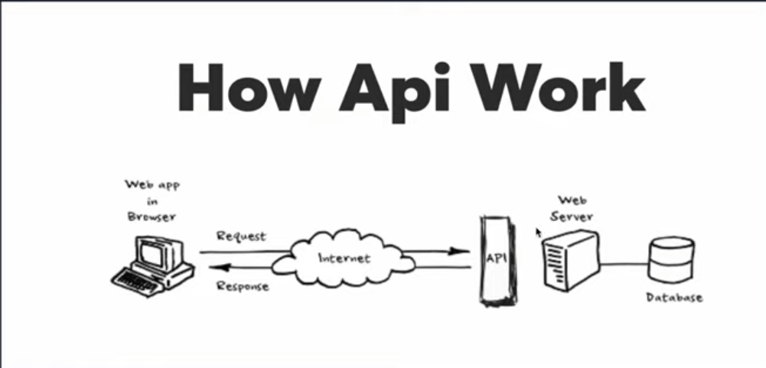

**What are REST APIs ?**

1. The representational state transfer (REST) architecture is perhaps the most popular approach to build APIs.

2. REST relies on a client/server approach which separates front and back ends of the API

Using HTTP Methods for RESTful Services

GET

POST

UPDATE

DELETE

**How to create APIs ?**

1. Node.js

2. Laravel

**Understanding JSON**

**JSON**

JSON stands for JavaScript Object Notation

JSON is a lightweight data-interchange format

JSON is plain text written in JavaScript object notation

JSON is used to send data between computers

JSON is language independent *

**JSON VALUE**

In JSON, values must be one of the following data types:

a string

a number

an object

an array

a boolean

null

**JSON OBJECT**

1. These {} represent json object which container json value it could be string, integer bool etc.

For example:

{"name":"John", "age":30, “car":null};

**Nested JSON Object**

Nested Json Object example:

{

"status": true,

"message": "Login Successfull",

“data”: {

"name": "Salman",

"&mail": "smkhanuet@gmail.com",

"age": "26",

}

}

**JSON ARRAY**

These square [] bracket represents array in programming language or List

Similarly in JSON it*has same structure to return value.

This is simple array which holds string value

["Ford", "BMW", ”Flat”]

{

"status": true,

‘message’: “User History’,

“data”: [

{

wig: 14,

“userid "2",

"game_type":"2-4-3",

“rugber’:"01 02.03 04 05 06"

“timestamps”: null,

"date": "27/08/2020",

“time”: "12:08:52 am*

}

],

“code”:200

}